BACK CONFERENCES

Structural Membranes 2011
V International Conference on Textile Composites and Inflatable StructuresTechnical University Eindhoven, The NetherlandsMembrane Mould

Conference Photos

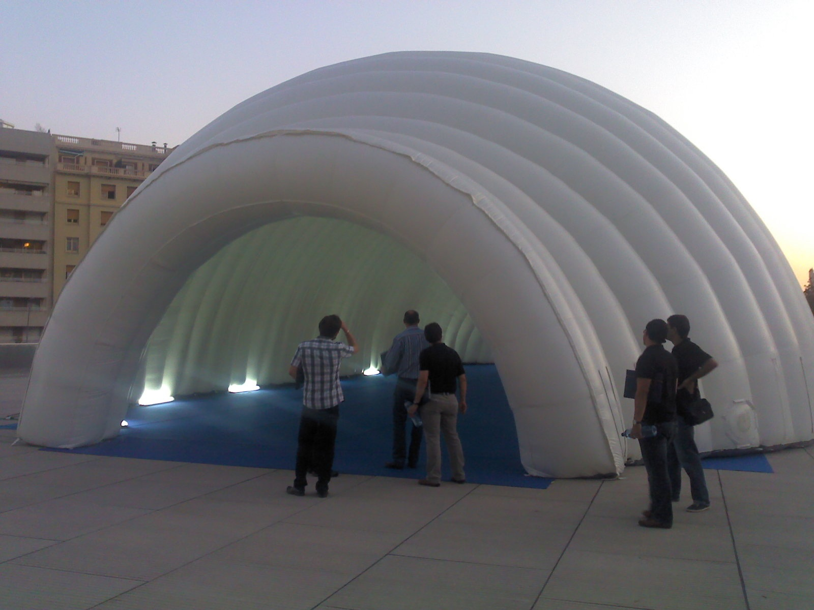Array
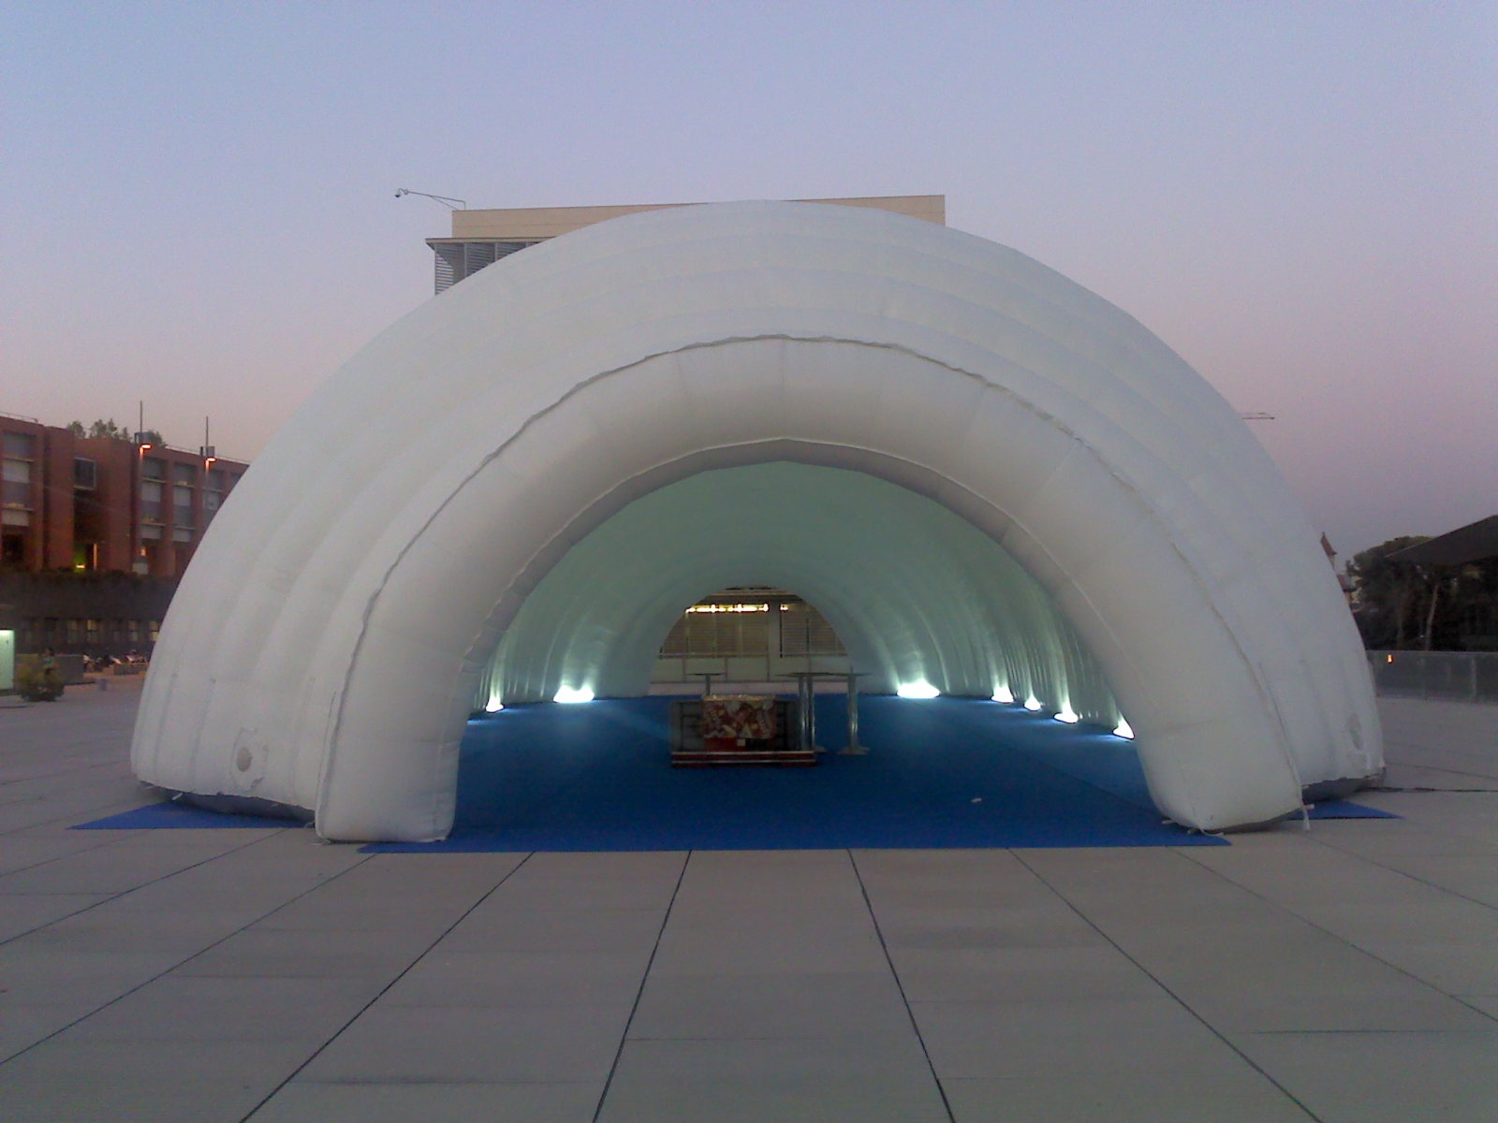Array
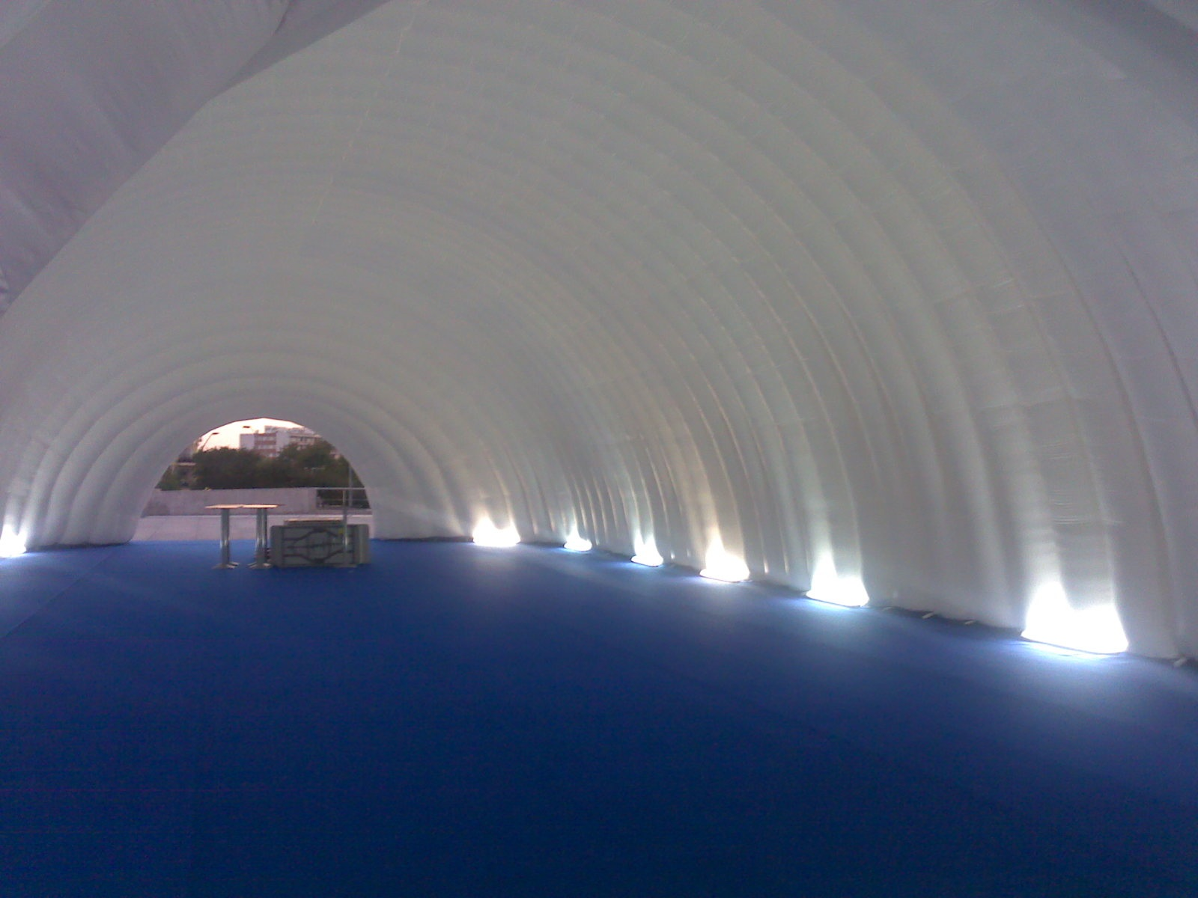Array
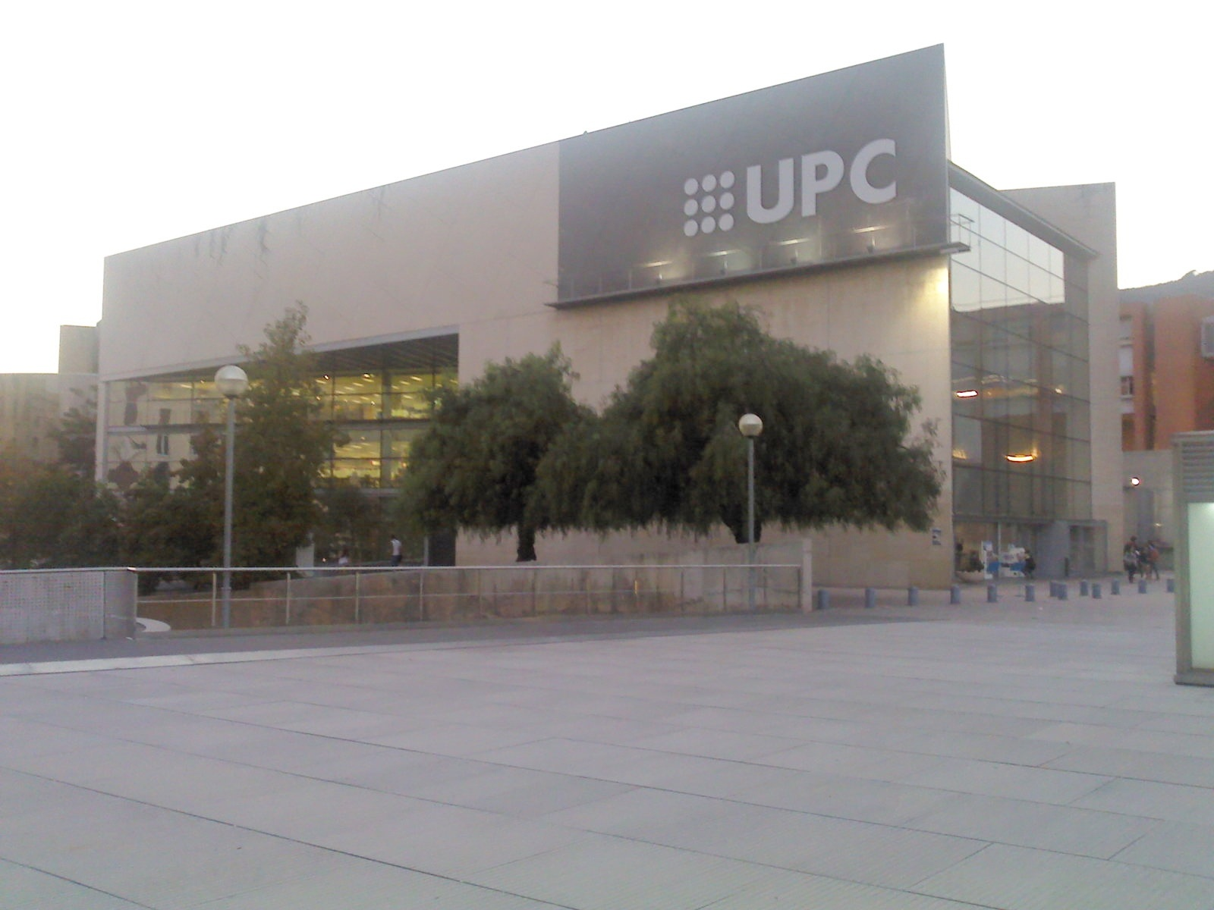Array
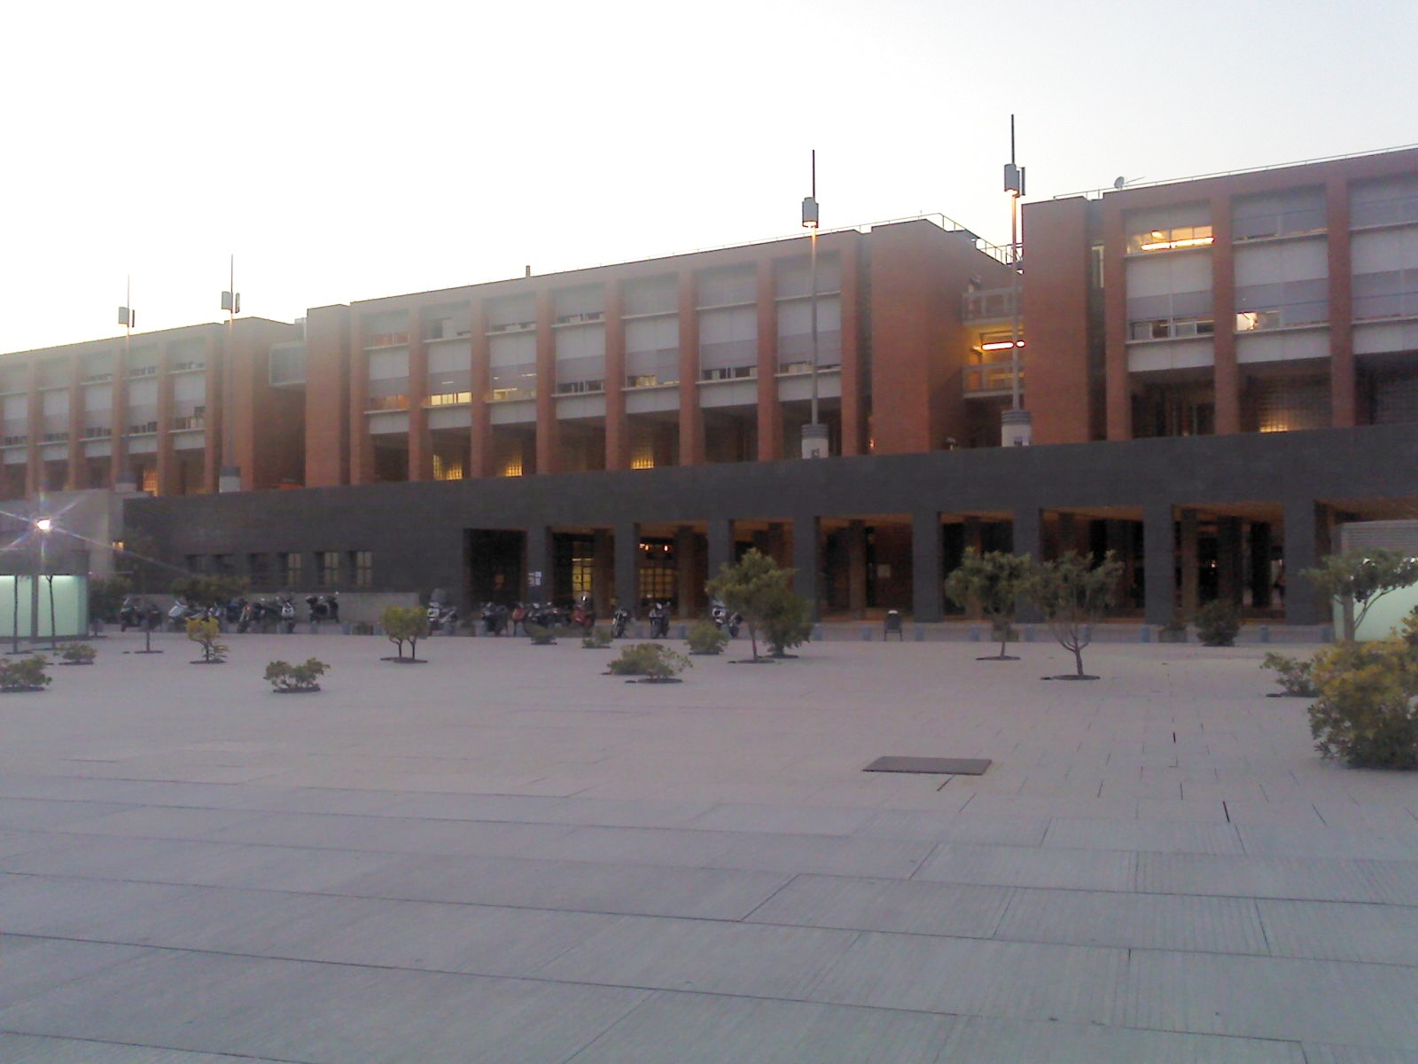Array

Conference Proceedings

External Links

